Order Of Service

Singing: Psalm 67—CW page 91

Reading: Psalm 132

Opening Hymn: TLH 324

Reading: James 2:14-26

Request Hymn: CW Supplement 748

Reading: Luke 19:1-10

Sermon Hymn: TLH 236

Sermon Text: Song Of Solomon 1:15

Doves’ Eyes

Prayer

The Apostles’ Creed, TLH page 12

Holy Communion

The Lord's Prayer

The Blessing

Closing Hymn: TLH 45

* * * * * * * * * * *

Bible Study: Lambs: I Samuel 2:18-20; 3:1-10; Little Jobs
Sheep: Proverbs 5:7-14; Your Choice
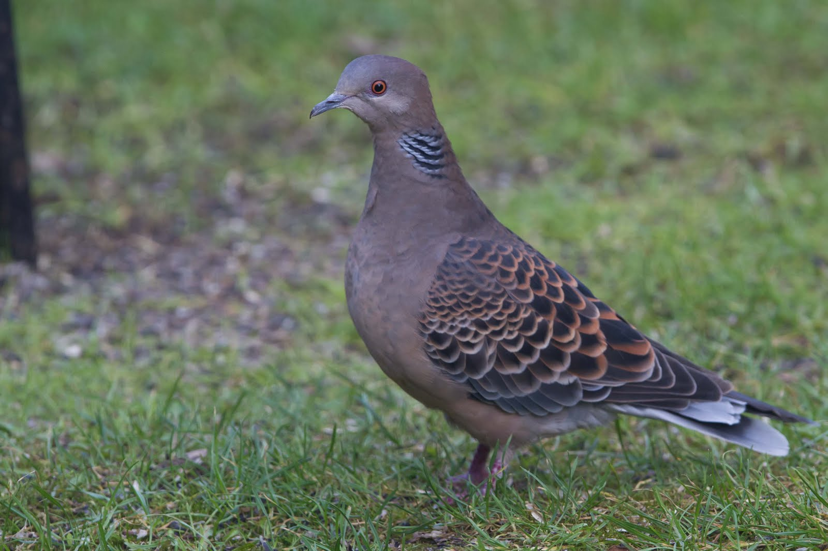

Doves’ Eyes

Water
Of
Life

27 September 2015

W A T E R O F L I F E

Independent Christian Church—Conservative Lutheran Doctrine

Worship Service: 9:30 a.m. Bible Study: 10:45 a.m.

Larry Cooper, Pastor E-Mail address:
111 N. Ridge Road lcooper@wateroflife.cc
Coon Valley, WI 54623 Web Site:
Phone: (608) 452-2105 www.wateroflife.cc

* * * * * * * * * * * * * * * * * * * * * * * * * * *

Sermon Text: Song Of Solomon 1:15

Doves’ Eyes

* * * * * * * * * * * * * * * * * * * * * * * * * * *

15: Behold, thou art fair, my love; behold, thou art fair; thou hast doves' eyes.

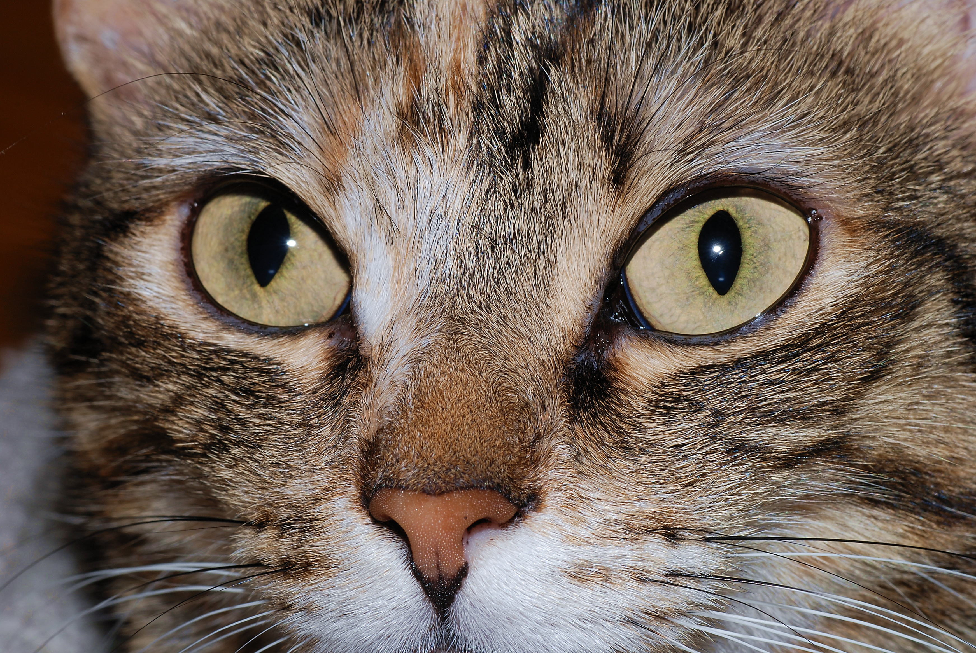
Eyes

In his famous Sermon on the Mount the Son of God said: The light of the body is the eye: if therefore thine eye be single, thy whole body shall be full of light.
But if thine eye be evil, thy whole body shall be full of darkness. If therefore the light that is in thee be darkness, how great is that darkness! Matthew 6:22-23.

The importance of the eye to the rest of the body cannot be overestimated.
Not only in the animal creation, but also in mankind.

It is instructive to notice what part the eye played back in Eden’s Garden:

And the serpent said unto the woman, Ye shall not surely die:
For God doth know that in the day ye eat thereof, then your eyes shall be opened, and ye shall be as gods, knowing good and evil.
And when the woman saw that the tree was good for food, and that it was pleasant to the eyes, and a tree to be desired to make one wise, she took of the fruit thereof, and did eat, and gave also unto her husband with her; and he did eat. Genesis 3:4-6.

Here in Song of Solomon 1:15, the Bridegroom (Jesus Christ) is praising the beauty of his Bride (the elect, his Church). And her beauty is so striking that he mentions it twice: : Behold, thou art fair, my love; behold, thou art fair! And the key to her beauty is in her eyes. Thou hast doves’ eyes!

So just what is it about doves’ eyes that makes the Bride of Jesus so beautiful?

We’ll pray for the guidance of the Holy Spirit and find out.

